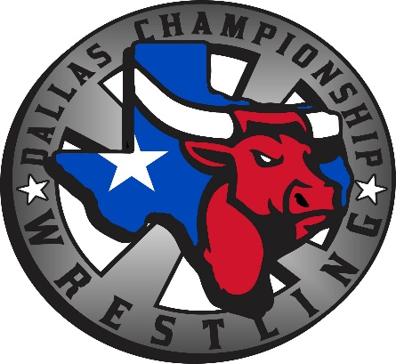

Dallas Championship Wrestling is excited to announce that it is bringing live championship wrestling to your area. We are committed to providing FUN, FAMILY FRIENDLY and exciting entertainment. DCW is providing an opportunity to businesses like yours to join in on this great business venture as a corporate sponsor. DCW will put your business logo in the program (PLEASE PROVIDE A PDF LOGO).

DCW OFFICIAL AFTER PARTY SPONSOR - $400 Per Event (Multiple Events Preferred)
(JOIN DCW WRESTLERS FOR THE OFFICIAL AFTER PARTY AT…“YOUR COMPANY”)
- Meet and greet with Wrestlers after the show at the bar
- Set a Table to Hand out literature
- 1 Month Ad on DCW website
- Ad in the Event Program
- 4 mentions from the Ring Announcer as a AFTER PARTY SPONSOR OF THE SHOW
- POTENTIAL 700 FANS TO ATTEND THE DCW SHOW.

SPONSOR NAME___________________________________________
ADDRESS:______ _____________________________________
EMAIL ADDRESS:________________________________________
PHONE NUMBER:__________________________________________________________
MAKE CHECKS PAYABLE TO TATUM ENTERPRISES
PayPal ACCEPTED AS WELL.
DATE OF SHOW: ______________

