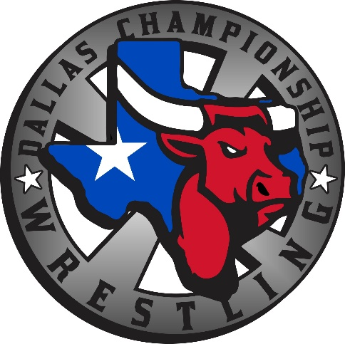

Dallas Championship Wrestling is excited to announce that it is bringing live championship wrestling to your area. We are committed to providing FUN, FAMILY FRIENDLY and exciting entertainment. DCW is providing an opportunity to businesses like yours to join in on this great business venture as a Corporate Program sponsor. DCW will put your business logo in the program (PLEASE PROVIDE A PDF LOGO).
As a corporate sponsor, you can choose what package that you want to take advantage of.

DCW OFFICIAL PROGRAM SPONSOR -(PRICES ARE PER EVENT. Multiple Events Discounts Available)
- $500 FULL PAGE AD AND ON DCW WEBSITE
- $300 HALF PAGE AD
- $300 OFFICIAL AFTER PARTY DESTINATION
- $150 QUARTER PAGE AD
- $100 BUSINESS CARD AD
- $200 30 DAYS ON DCW WEBSITE
- $100 YOU GET ADDED TO THE SPONSOR BANNER

SPONSOR NAME___________________________________________________________
ADDRESS:________________________________________________________________
EMAIL ADDRESS:___________________________________________________________
PHONE NUMBER:__________________________________________________________
CHECKS MADE OUT TO TATUM ENTERPRIZES
PayPal accepted as well.
DATE OF SHOW: __________________

